**Intro to Network Traffic Analysis HackTheBox**

Capturing with TCMPDUMP -Fundamentals LAB

**Task #1**

Validate Tcpdump is installed on our machine.

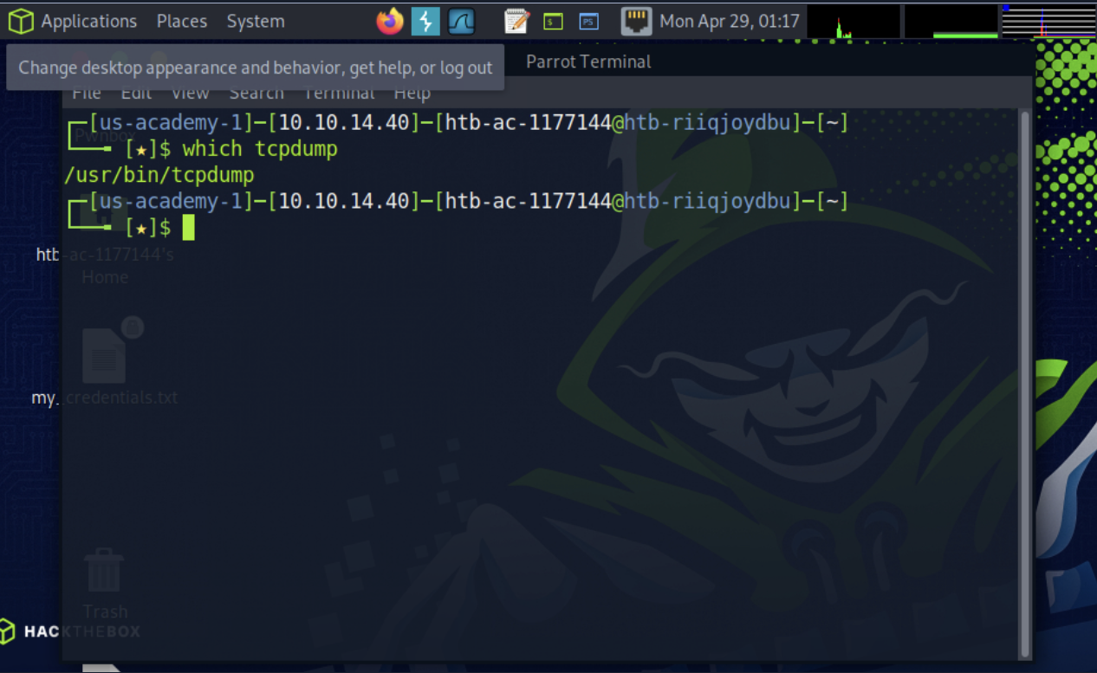

**Task #2**

Start a capture.

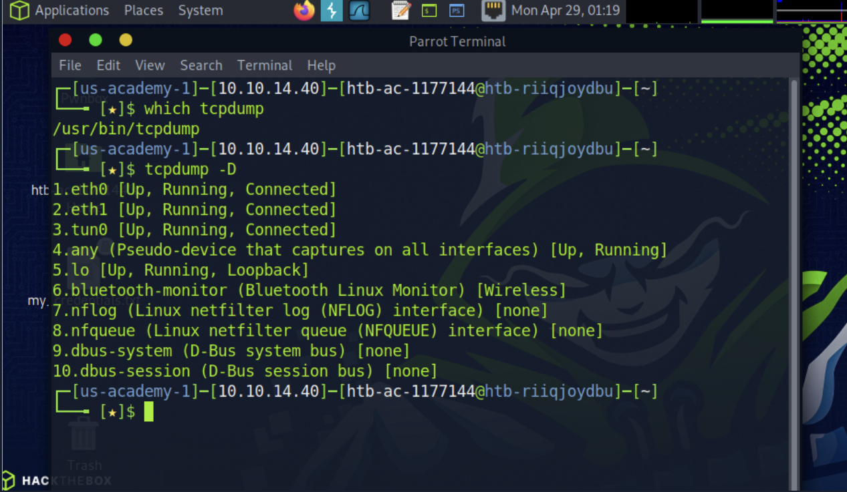

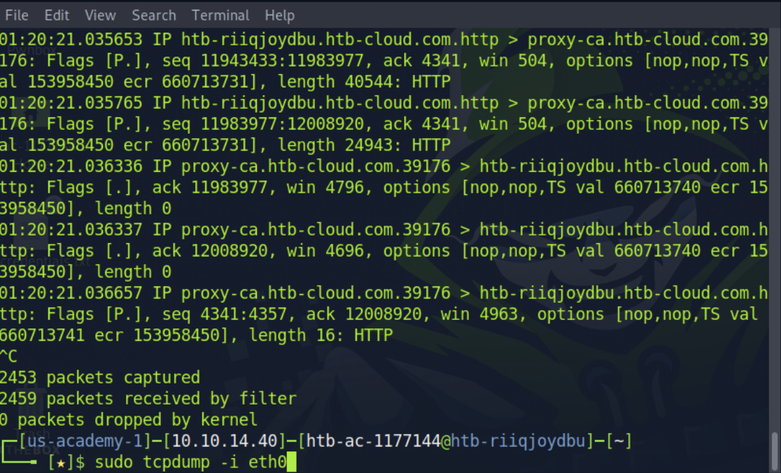

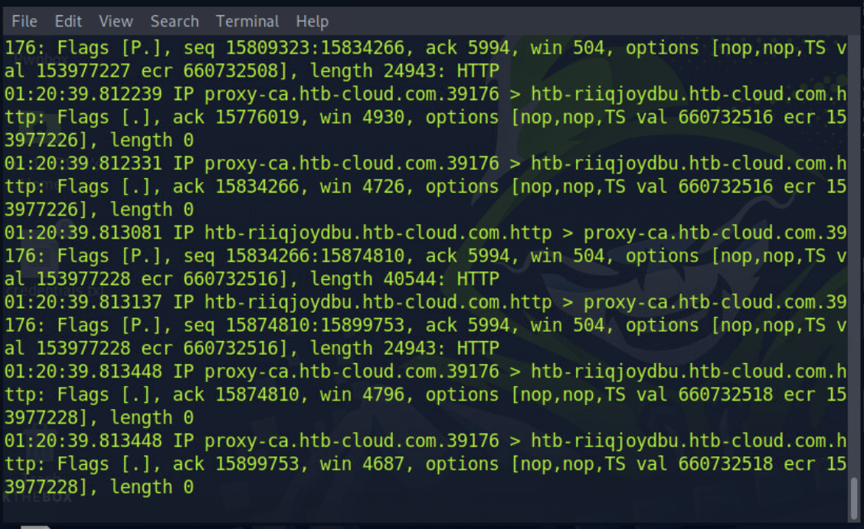

**Task #3**

Utilize Basic Capture Filters.

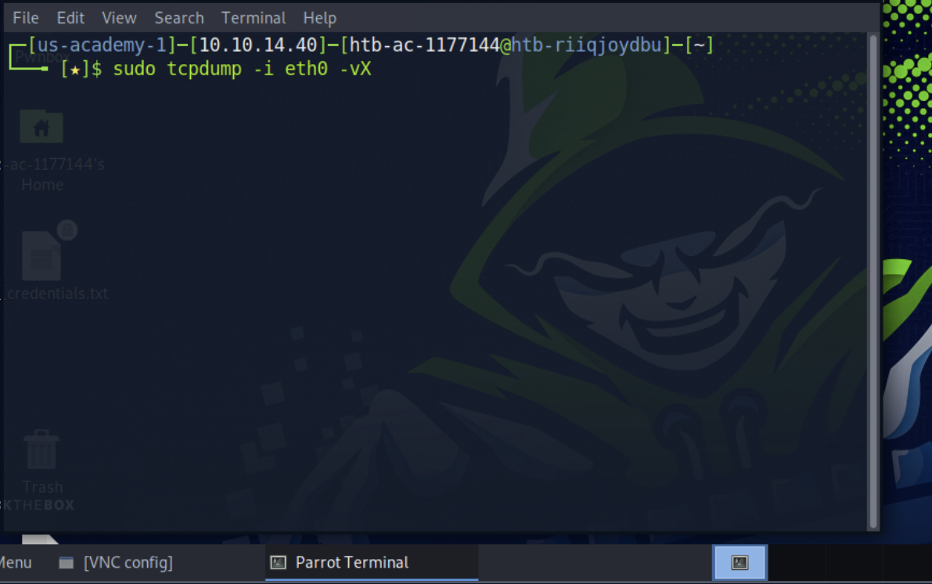

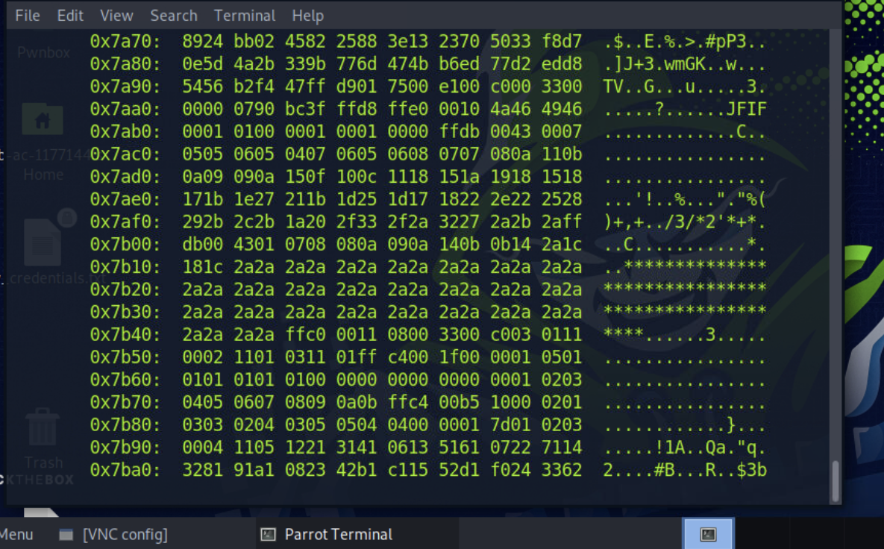

**Task #4**

Save a Capture to a .PCAP file.

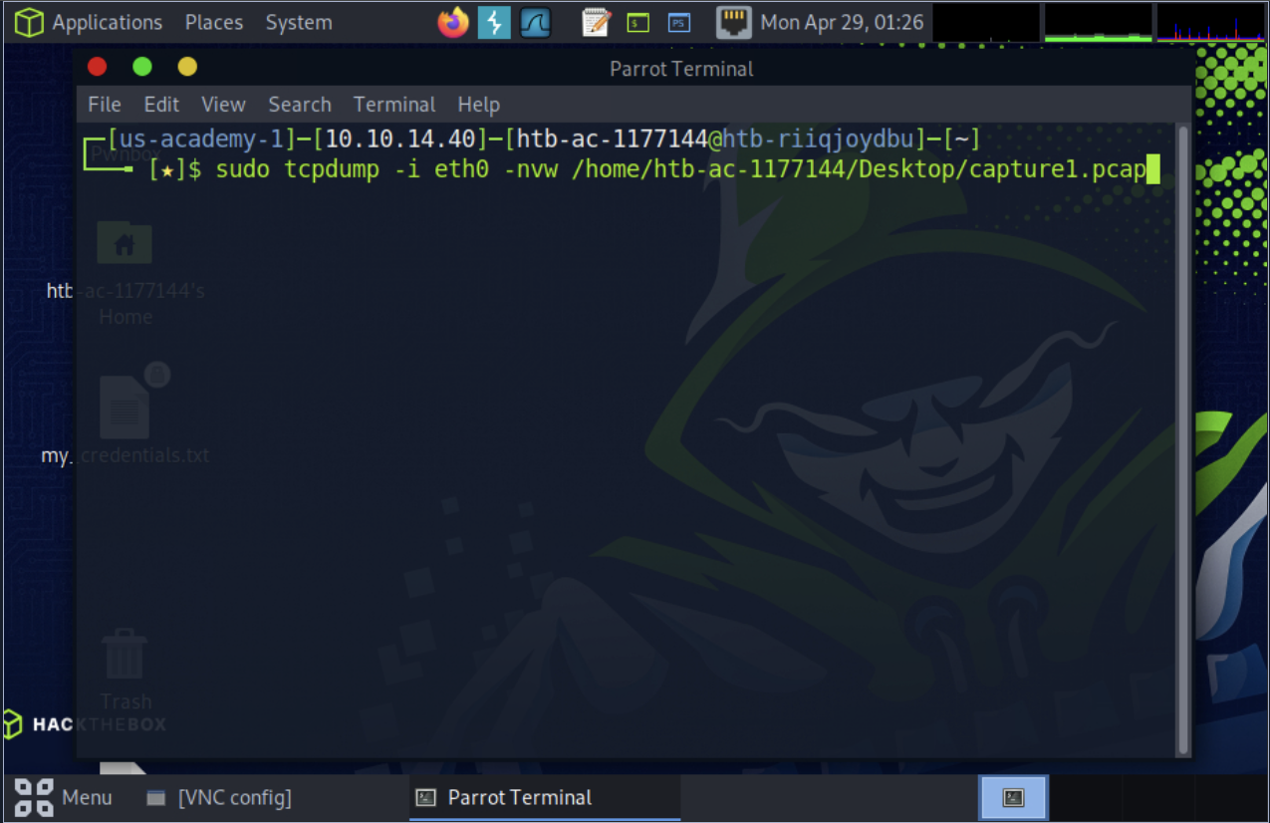

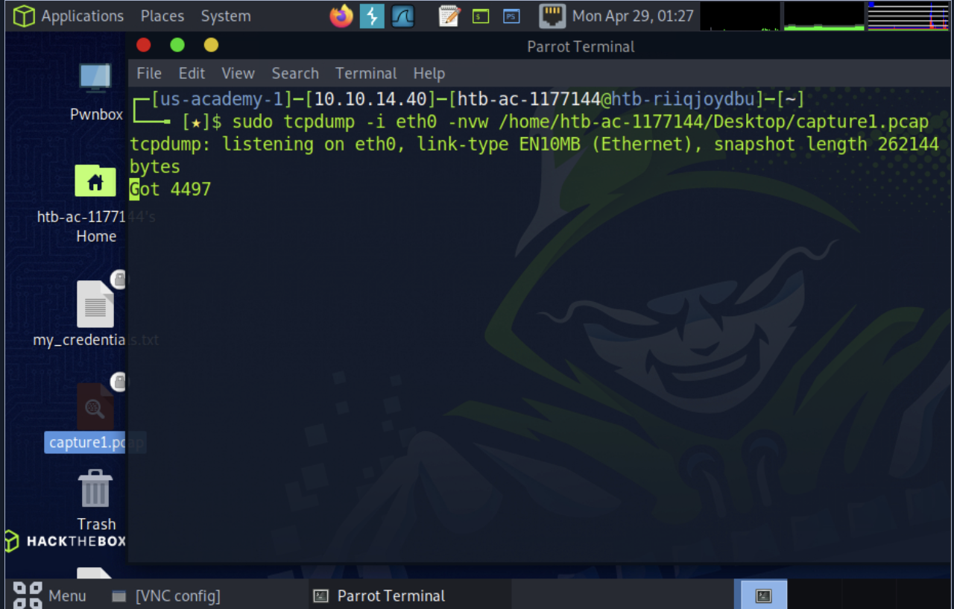

**Task #5**

Read the Capture from a .PCAP file.

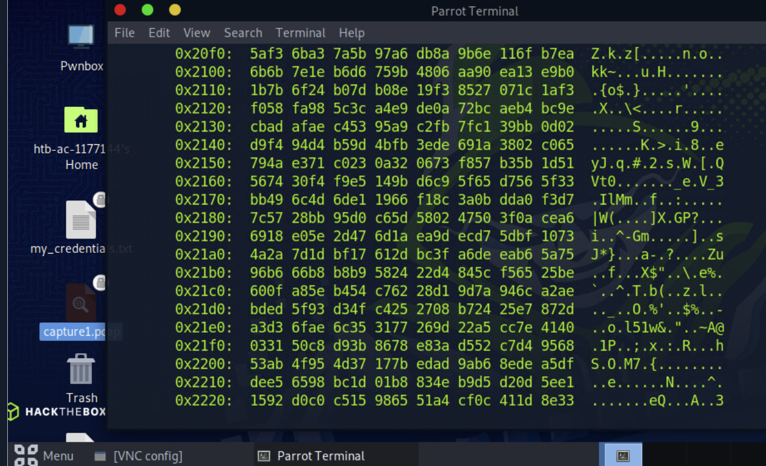

**Interrogating Network Traffic With Capture and Display Filters**

**Task #1**

Read a capture from a file without filters implemented.

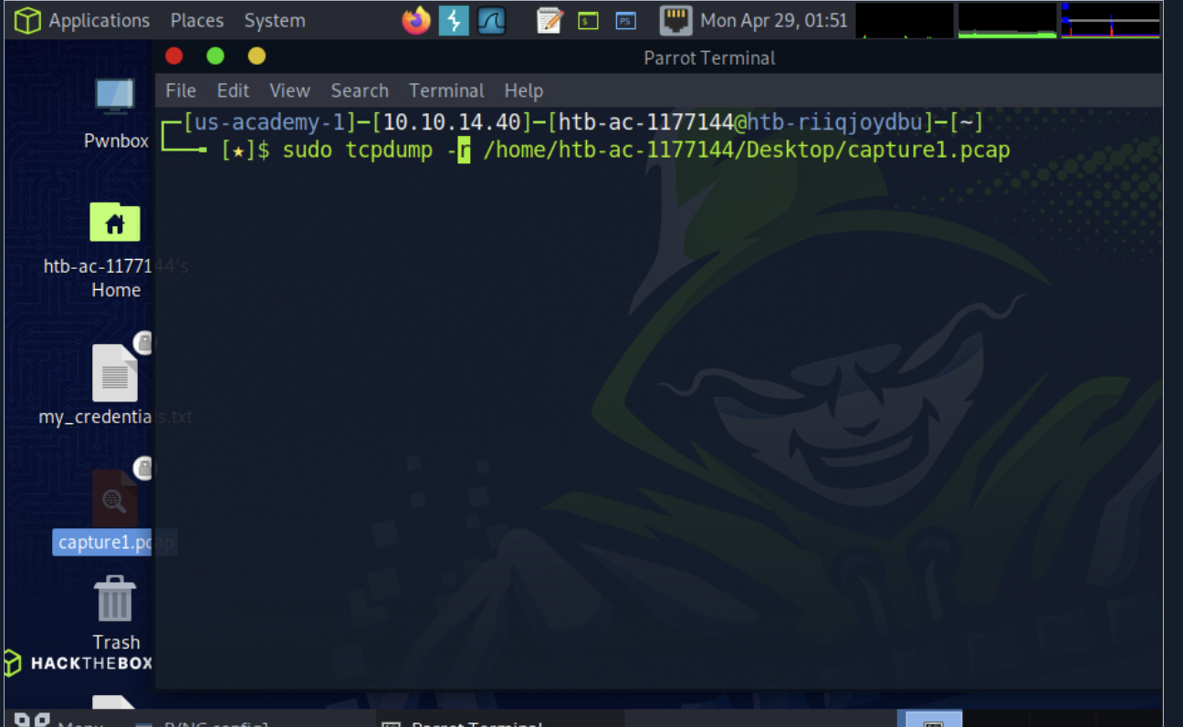

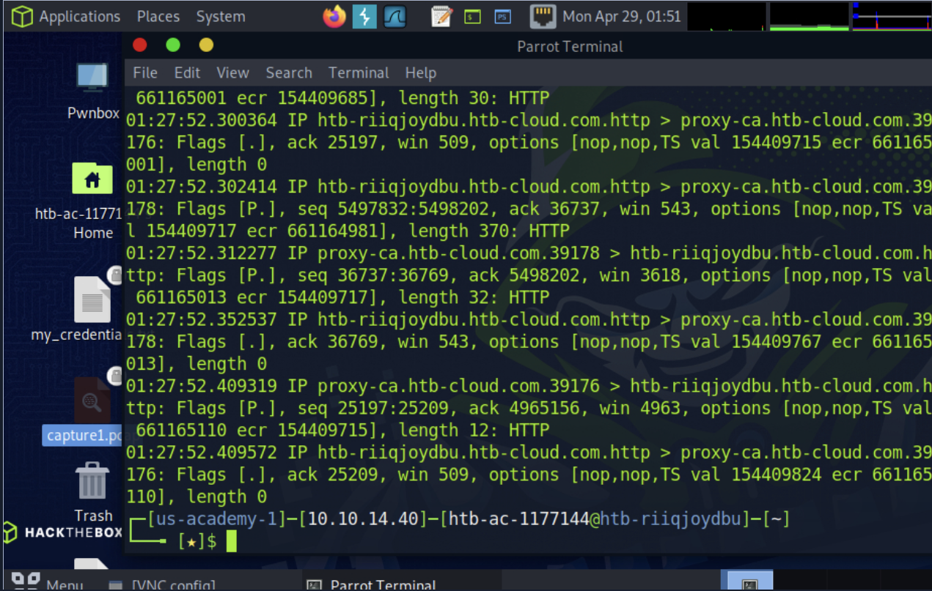

**Task #2**

Identify the type of traffic seen.

Common protocols: We should notice a bunch of DNS, HTTP, and HTTPS traffic.

Ports utilized: 53 80 443

**Task #3**

Identify conversations.

To help make this more straightforward, turning absolute sequence numbers on (-S) will be extremely helpful in determining conversations.

We can also examine the different hosts involved. Servers typically communicate over the well-known port number assigned to the protocol (80 for HTTP, 443 for HTTPS, for example). Hosts or recipients in the conversations will typically utilize a random high port number.

**Task #4**

Interpret the capture in depth.

To determine the correct timestamp: Read the file with (-r) and then examine the conversations. Find the first one established ( Full TCP Handshake "Syn / SYN-ACK / ACK") and look at the first field in the output to find the timestamp. To find the IP of Host ( ), we can filter the traffic only to see conversations Sourcing from it ( src 'name-of-host' ) and then disable Name resolution with (-n). To determine the protocol being utilized in the first conversation, look for the well-known port # while disabling hostname and port name resolution (-nn) or leave off the (-nn), and it will tell you the name of the protocol in the output.

**Task #5**

Filter out traffic.

Harsh1208@htb[/htb]**$** sudo tcpdump -r (file.pcap) udp and port 53

**Familiarity With Wireshark**

**Task #1**

Validate Wireshark is installed, then open Wireshark and familiarize yourself with the GUI windows and toolbars.

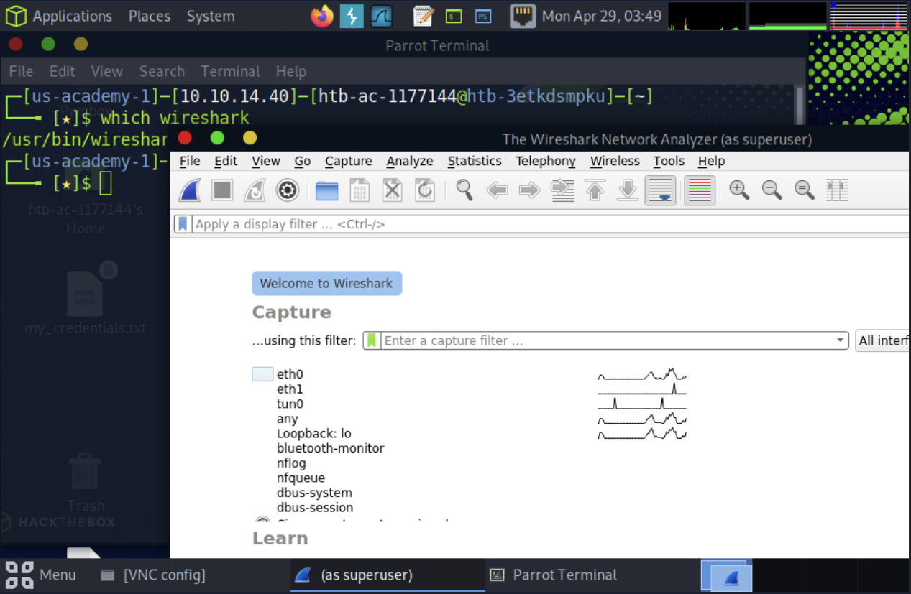

**Task #2** Select an interface to run a capture on and create a capture filter to show only traffic to and from your host IP.

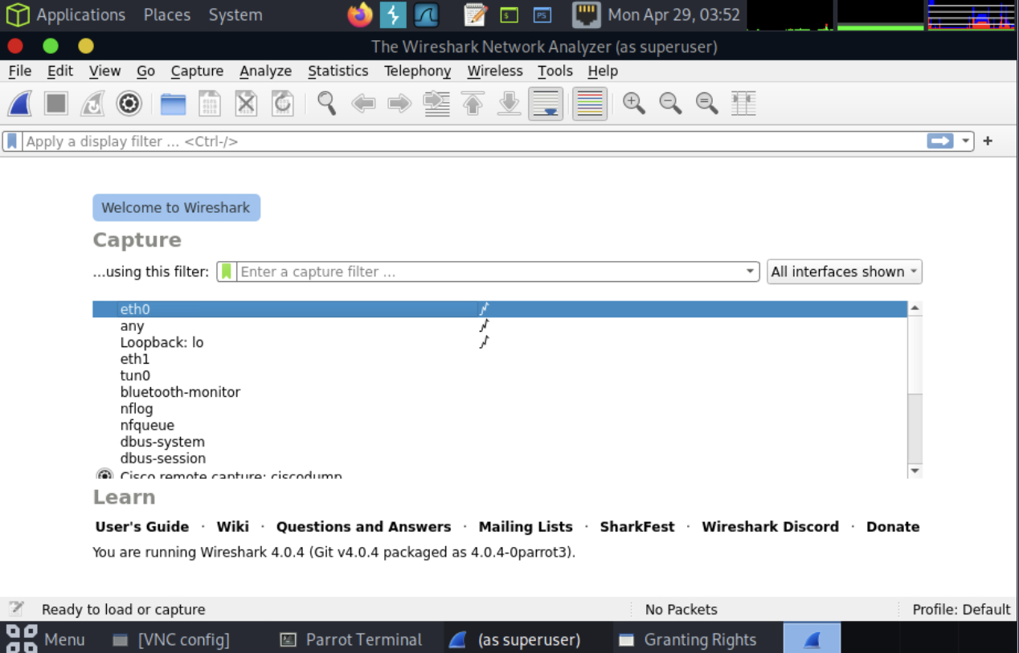

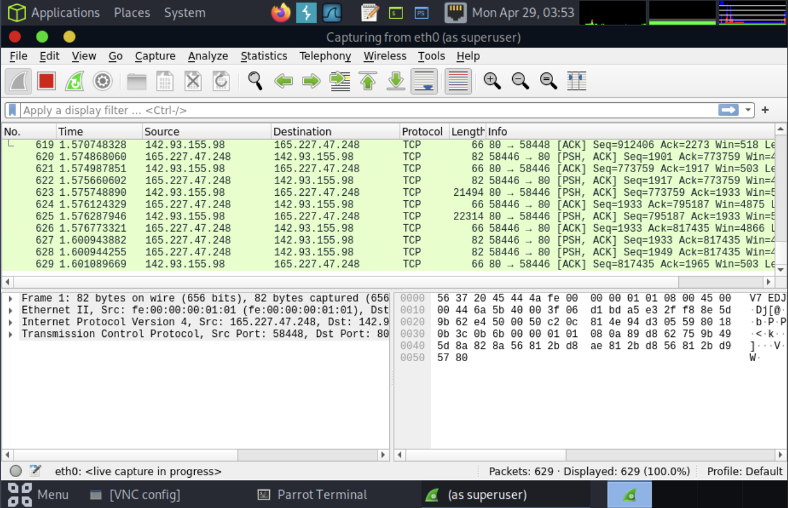

**Task #3**

Create a capture filter.

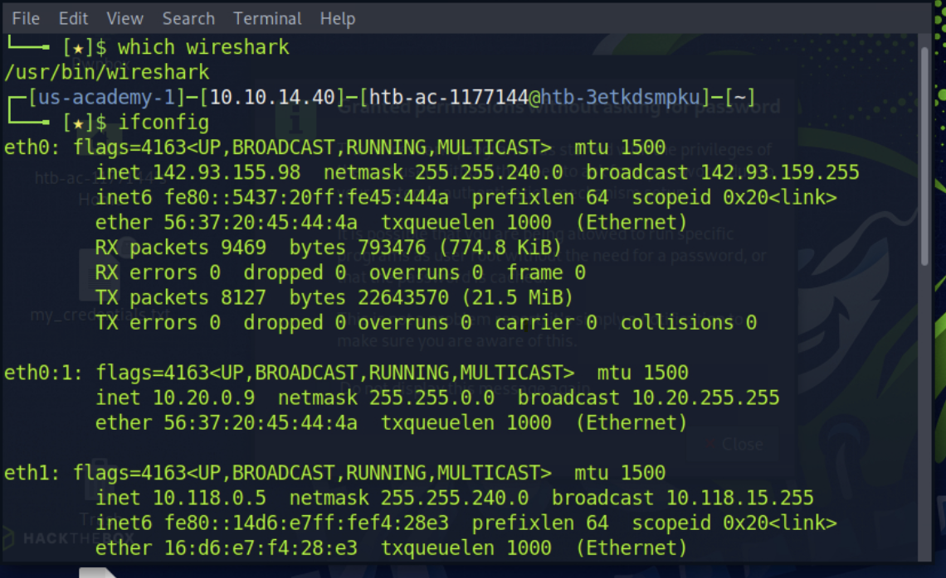

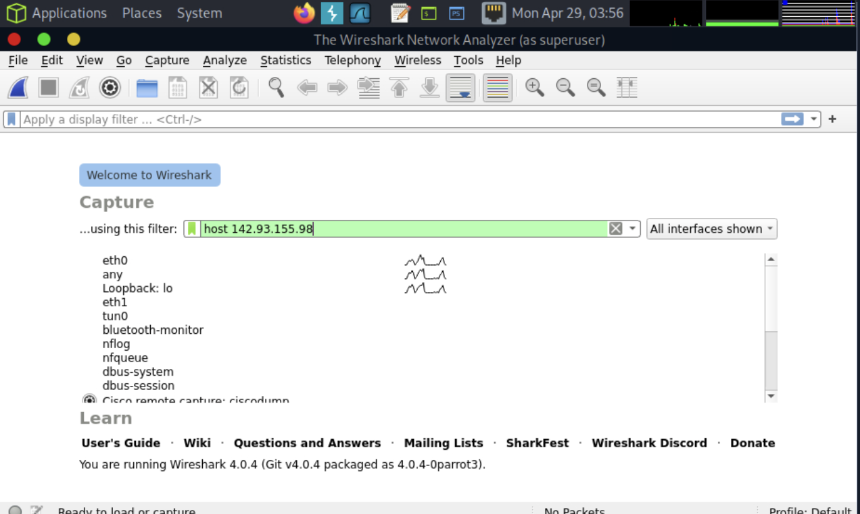

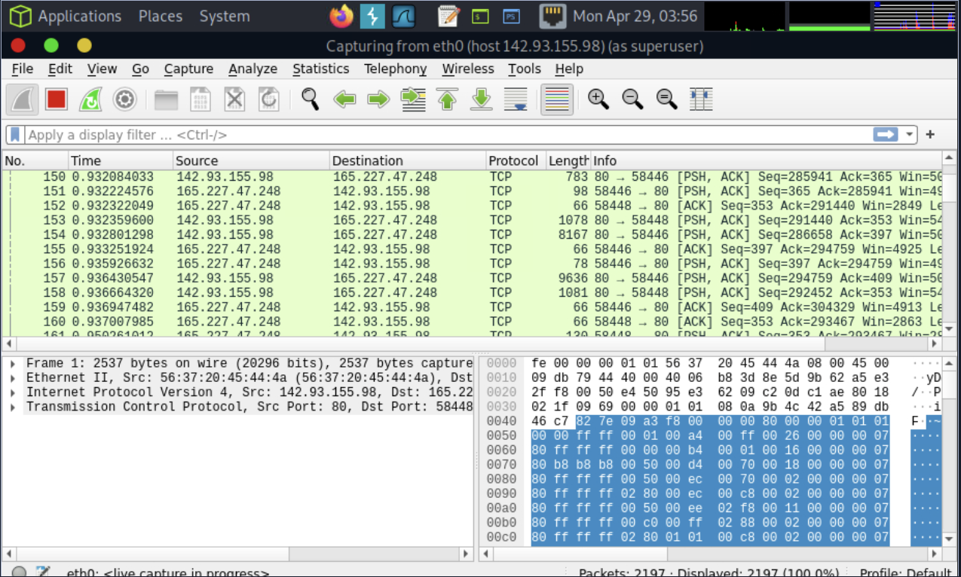

**Task #4**

Navigate to a webpage to generate some traffic.

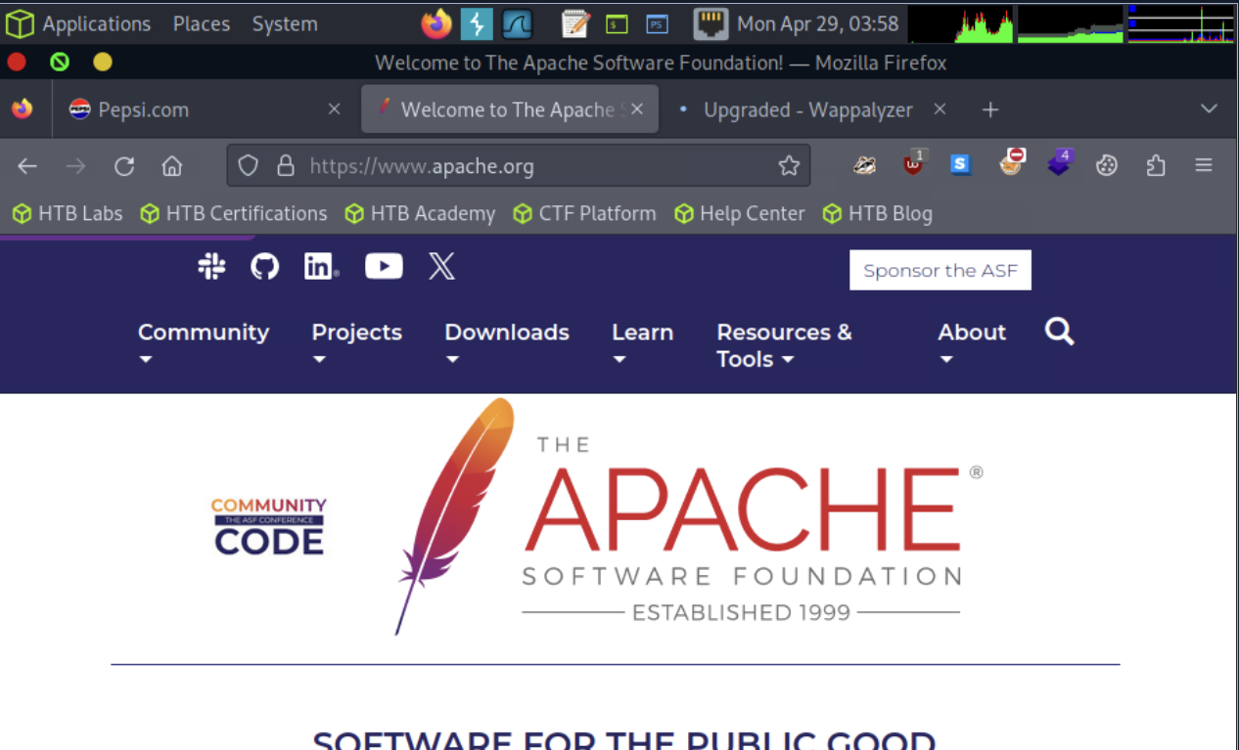

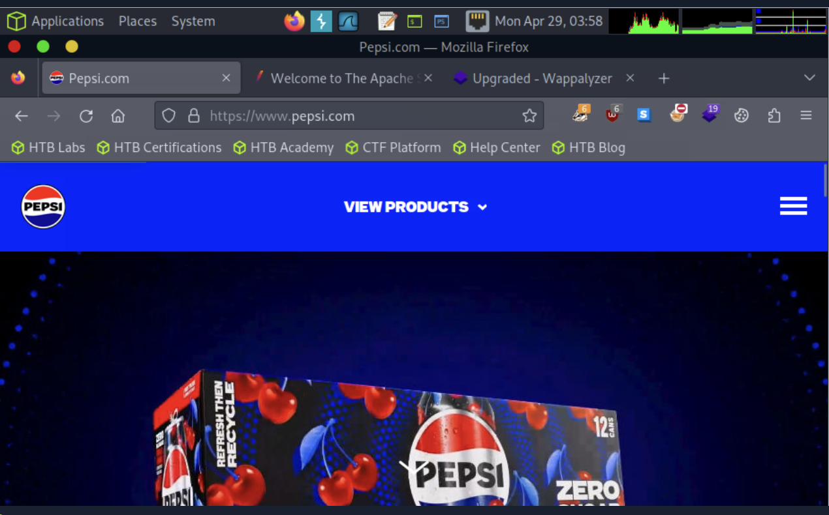

**Task #5**

Use the capture results to answer the following questions.

Are multiple sessions being established between the machine and the webserver? How can you tell?

What application-level protocols are displayed in the results?

Can we discern anything in clear text? What was it?

When visiting pepsi.com and http://apache.org you would have gotten several different streams and many different protocols. DNS to request the records for the pages, HTTP for the apache.org site, HTTPS for Pepsi.com, along with any other traffic happening in your network segment at the time. If you noticed a difference between the traffic, you are on the right track. If you look at the output from apache.org it will be in plain text. This happens because HTTP is not encrypted. Looking at HTTPS traffic will be much different, however.

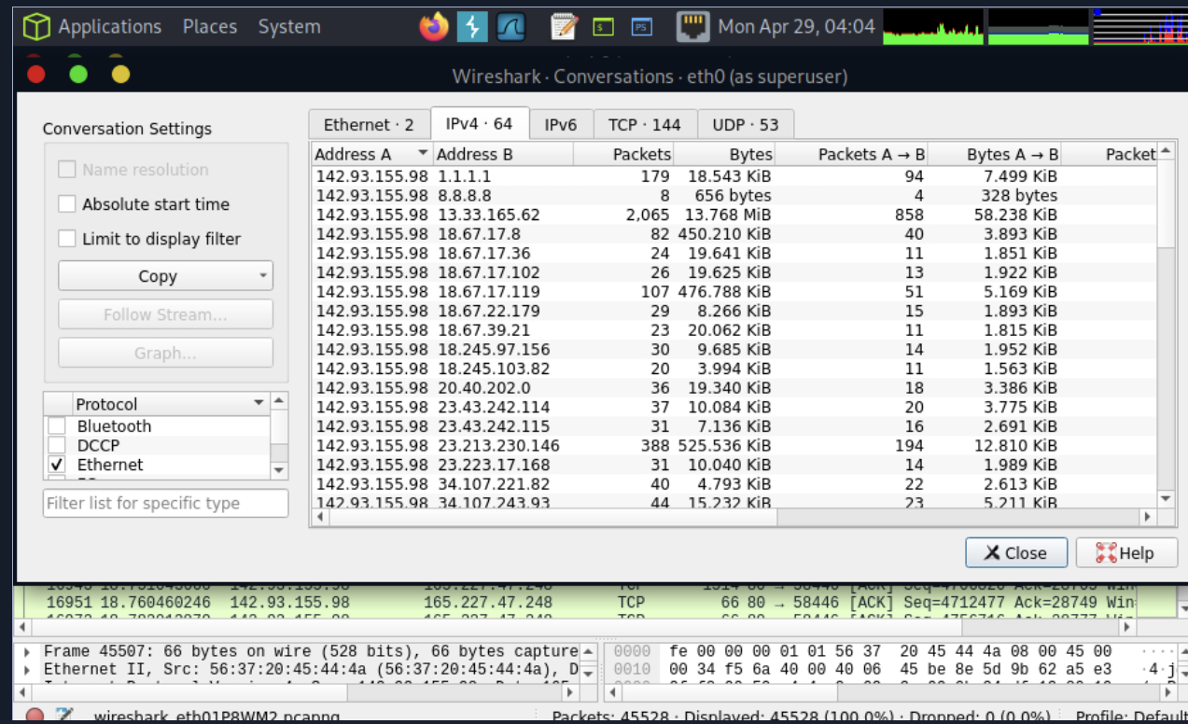

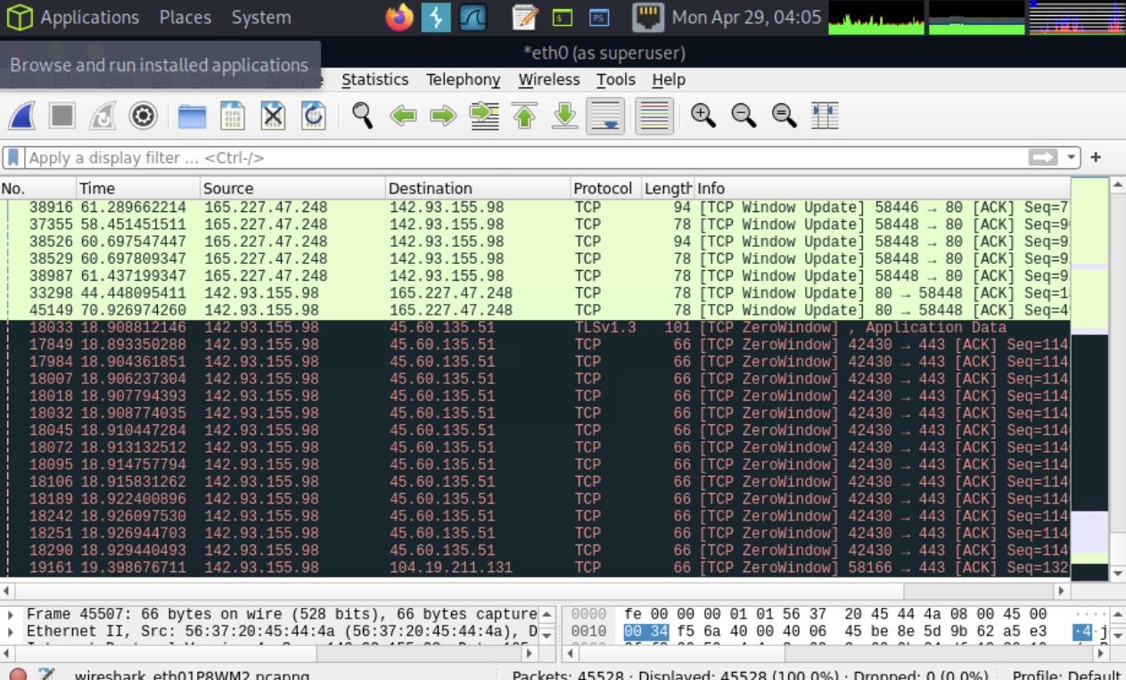

**Packet Inception, Dissecting Network Traffic With Wireshark**

**Task #1**

Open a pre-captured file (HTTP extraction)

In Wireshark, Select File → Open → , then browse to Wireshark-lab-2.pcap. Open the file.

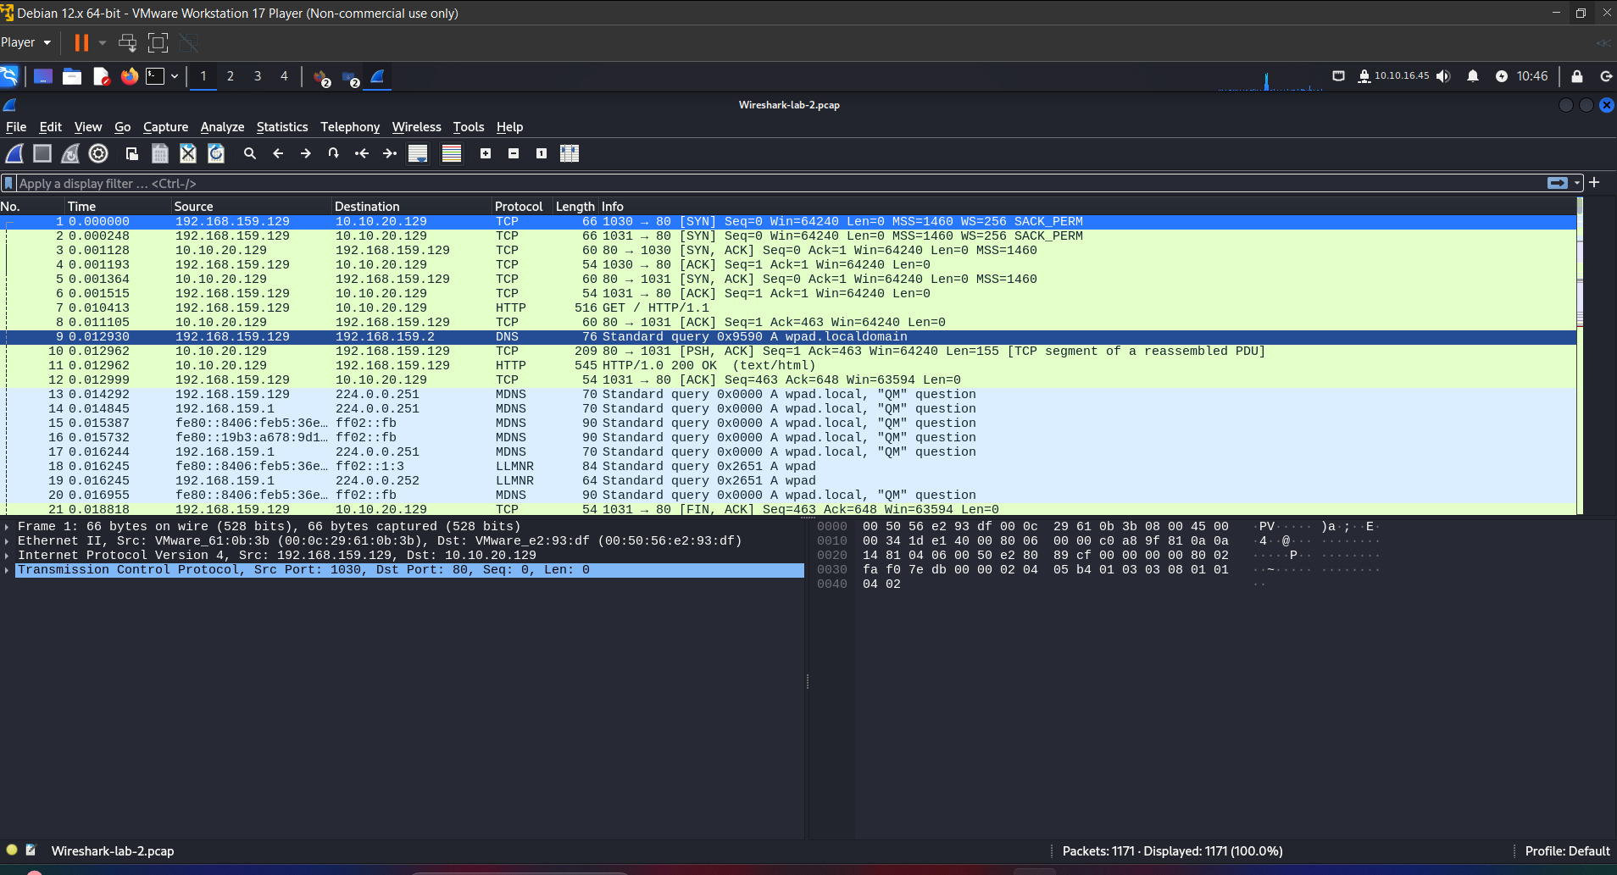

**Task #2**

Filter the results.

Now that we have the pcap file open in Wireshark, we can see quite a lot of traffic within this capture file. It has around 1171 packets total, and of those, less than 20 are HTTP packets specifically. Take a minute to examine the pcap file, become familiar with the conversations being had while thinking of the task to accomplish. Our goal is to extract potential images embedded for evidence. Based on what has been asked of us, let's clear our view by filtering for HTTP traffic only.

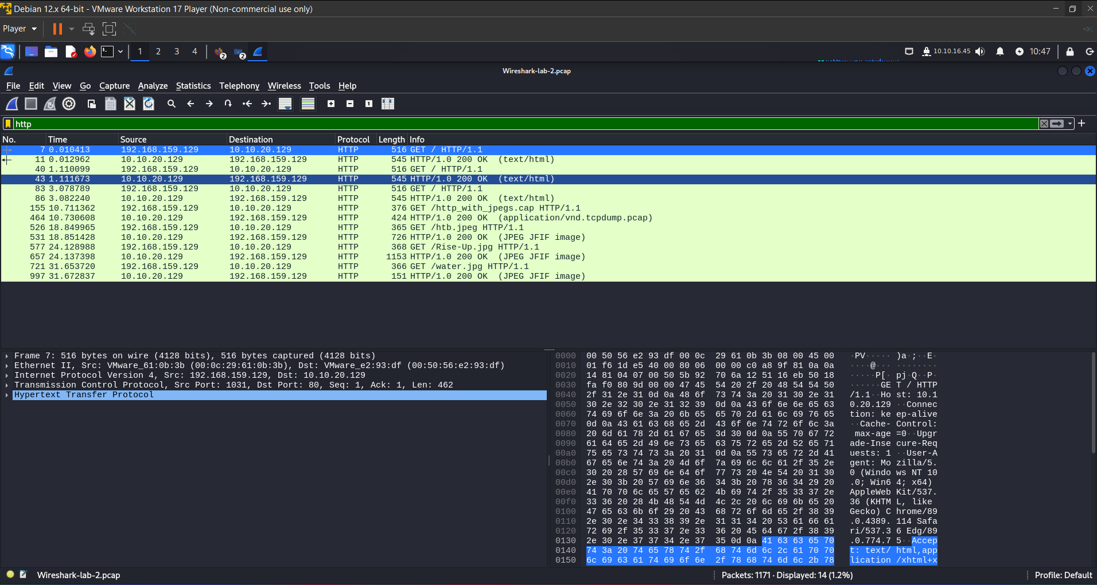

**Task #3**

Follow the stream and extract the item(s) found.

So now that we have established there is HTTP traffic in this capture file, let's try to grab some of the items inside as requested. The first thing we need to do is follow the stream for one of the file transfers. With our http filter still applied, look for one of the lines in which the Web Server responds with a “200 OK” message which acts as an acknowledgment/receipt to a users’ GET request. Now let's select that packet and follow the TCP stream.

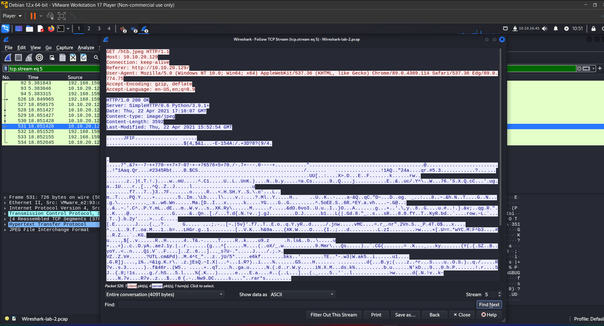

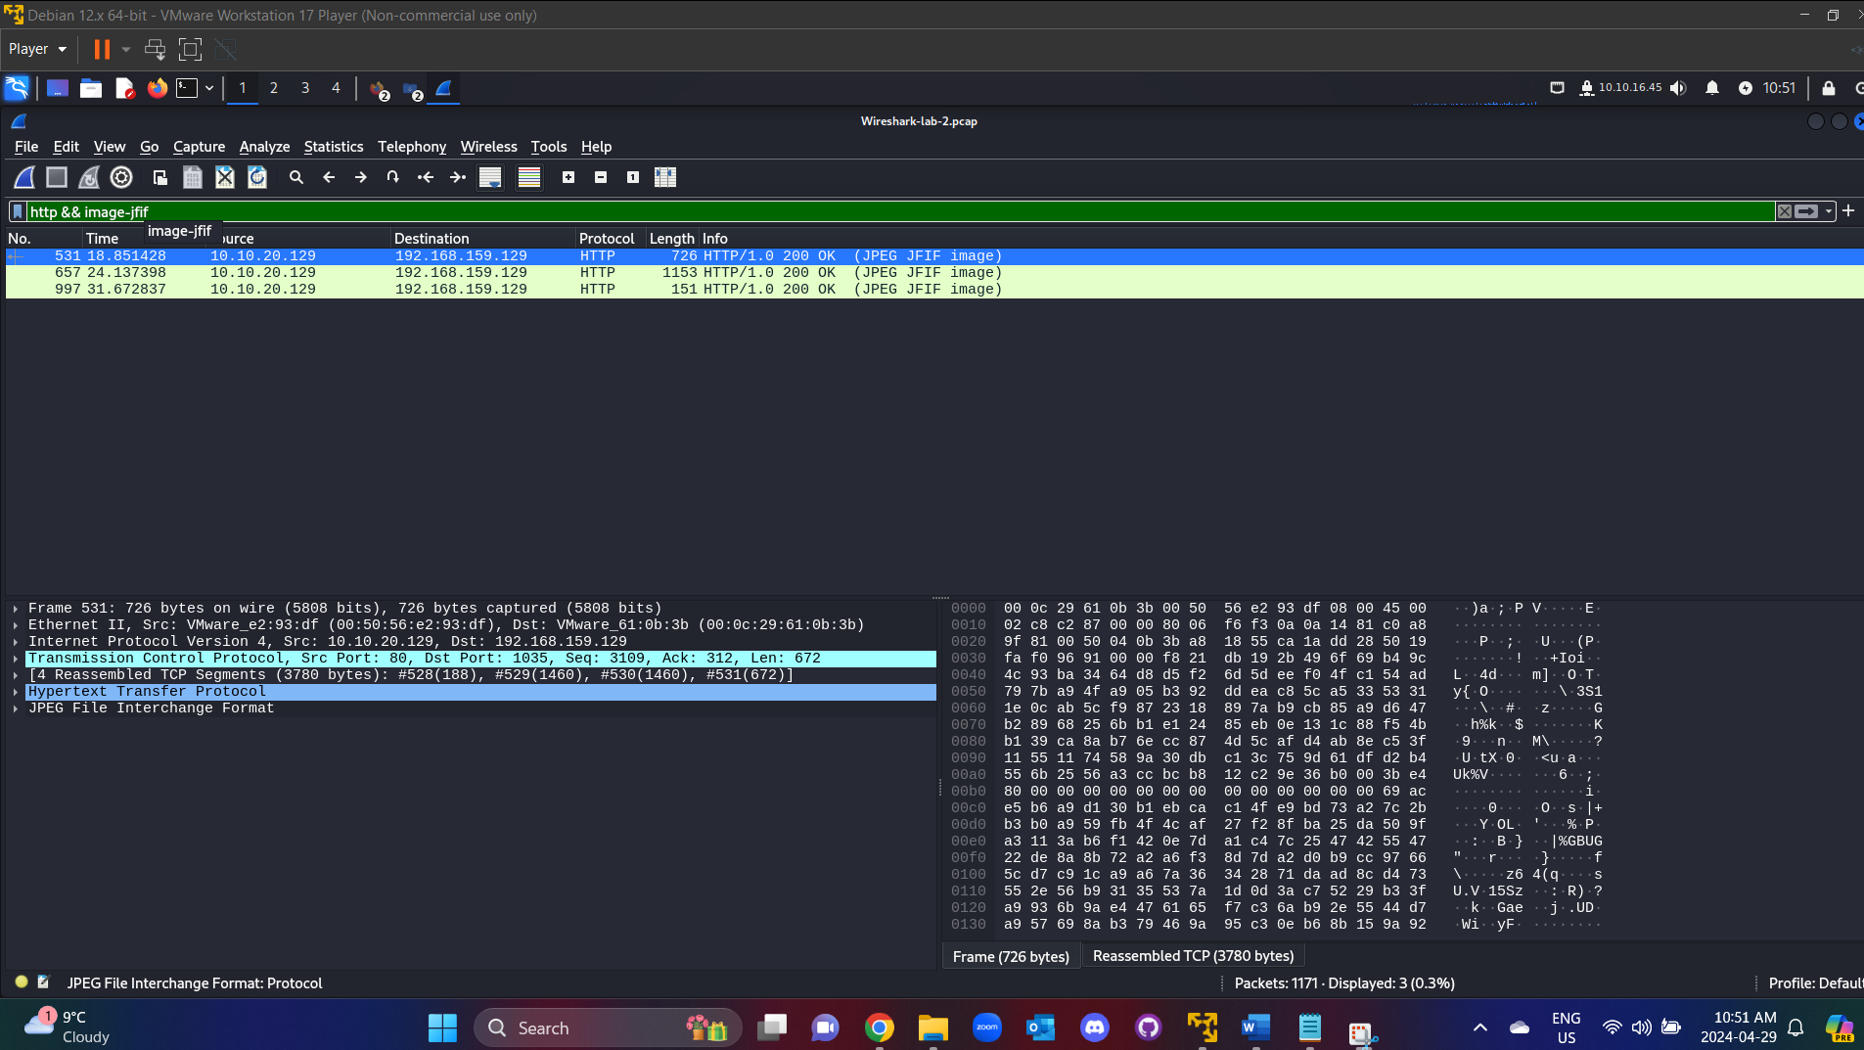

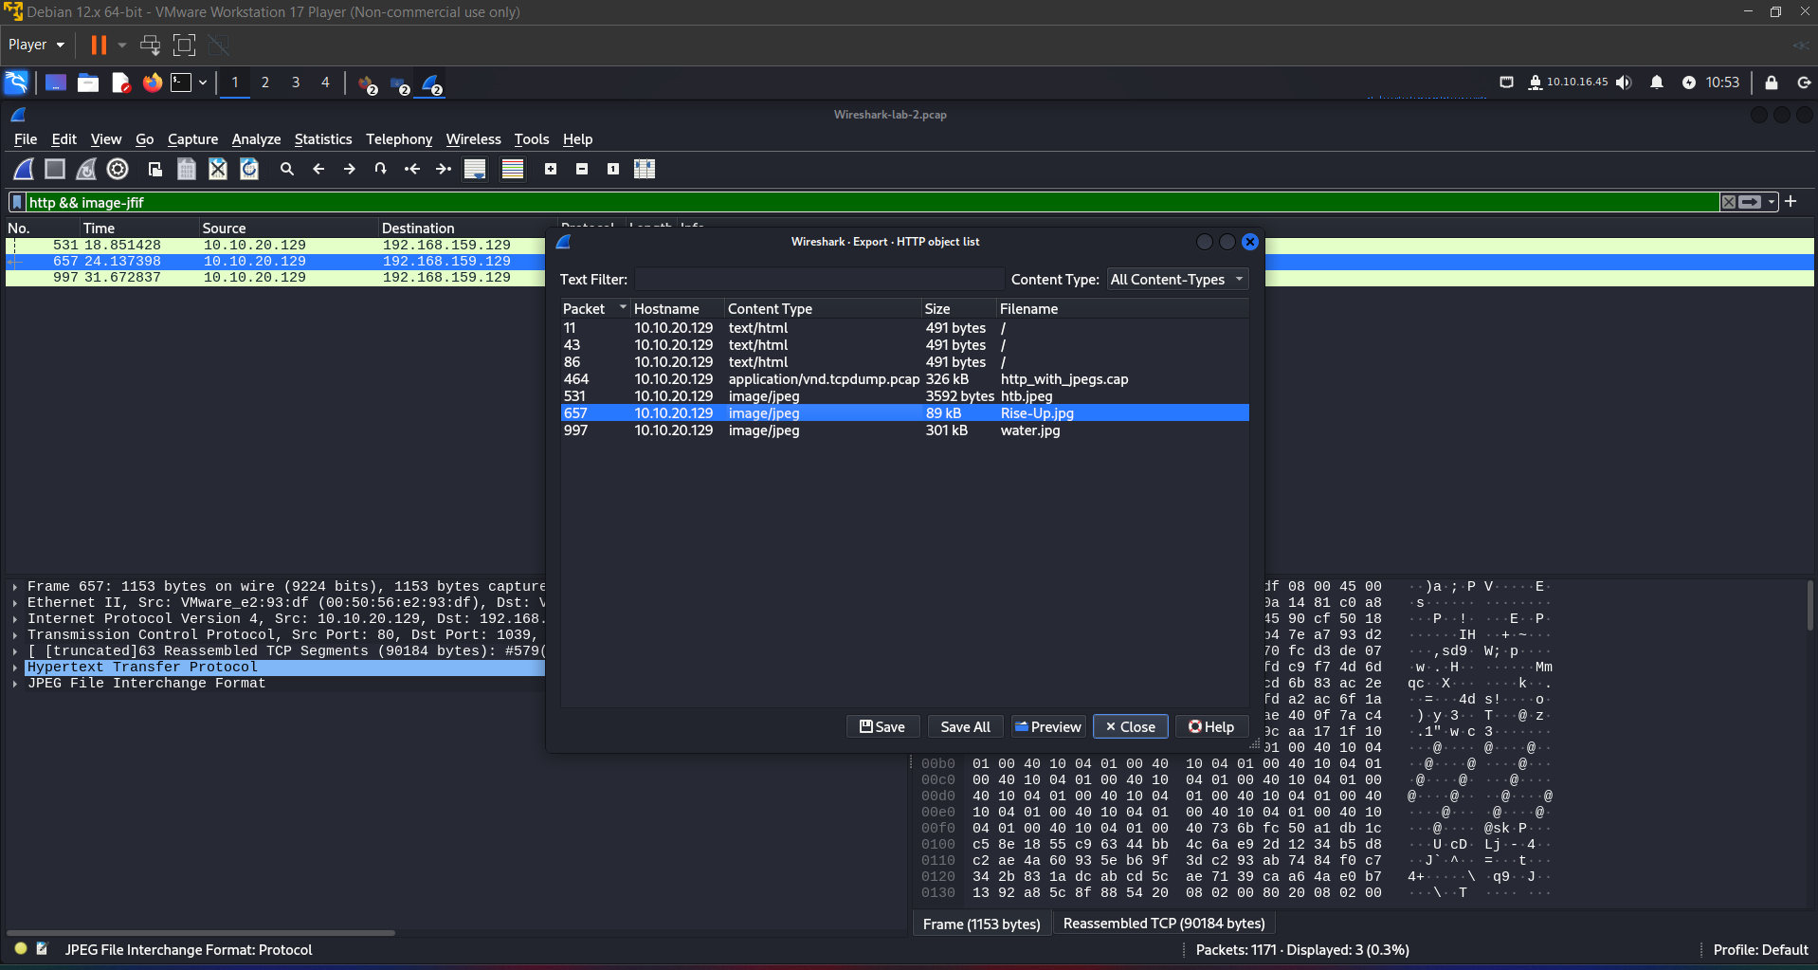

**Guided Lab: Traffic Analysis Workflow**

**Task #1**

Connect to the live host for capture.

Analysis

Follow this workflow template and examine the suspicious traffic. The goal is to determine what is happening with the host in question.

1. what is the issue?
   1. a brief summary of the issue.
2. define our scope and the goal (what are we looking for? which time period?)
   1. Scope: what are we looking for, where?
   2. when the issue started:
   3. supporting info: Files, data sources, anything helpful.
3. define our target(s) (net / host(s) / protocol)
   1. Target hosts: Network or address of hosts.
4. capture network traffic / read from previously captured PCAP.
   1. Perform actions as needed to analyze the traffic for signs of intrusion.
5. identification of required network traffic components (filtering)
   1. once we have our traffic, filter out any traffic not necessary for this investigation to include; any traffic that matches our common baseline, and keep anything relevant to the scope of the investigation.
6. An understanding of captured network traffic
   1. Once we have filtered out the noise, it's time to dig for our targets. Start broad and close the circle around our scope.
7. note taking / mind mapping of the found results.
   1. Annotating everything we do, see, or find throughout the investigation is crucial. Ensure you are taking ample notes, including:
   2. Timeframes we captured traffic during.
   3. Suspicious hosts/ports within the network.
   4. Conversations containing anything suspicious. ( to include timestamps, and packet numbers, files, etc.)
8. summary of the analysis (what did we find?)
   1. Finally, summarize what has been found, explaining the relevant details so that superiors can decide to quarantine the affected hosts or perform a more critical incident response mission.
   2. Our analysis will affect decisions made, so it is essential to be as clear and concise as possible.

This task was best completed using the PCAP file provided for the lesson. Following the steps in the workflow, we filled in the information and performed our analysis.

1. what is the issue?
   1. Suspicious traffic coming from within the network.
2. define our scope and the goal (what are we looking for? which time period?)
   1. target: traffic is originating from 10.129.43.4
   2. when: within the last 48 hours. Capture traffic to determine if it is still happening.
   3. supporting info: file: NTA-guided.pcap
3. define our target(s) (net / host(s) / protocol)
   1. scope: 10.129.43.4 and anyone with a connection to it. Unknown protocol over port 4444.
4. capture network traffic
   1. plug into a link with access to the 10.129.43.0/24 network to capture live traffic attempting to see if anything is happening.
   2. We have been given a PCAP with historical data that contains some of the suspect traffic. We will examine this to analyze the issue.
5. identification of required network traffic components (filtering)
   1. First, we will filter out anything that does not have a connection to 10.129.43.4, since this is our primary suspicious target for the moment.

After checking out the conversations plugin pictured above, we can see there are only three conversations captured in this pcap file, and they all pertain to our suspicious host. Next, we will look at the protocol hierarchy plugin to see what our traffic is.

We can see here that this PCAP is mostly TCP traffic, with a bit of UDP traffic. Since there is less UDP than TCP traffic, let us look into that first.

1. Once we have filtered out the noise, it's time to dig for anything unusual. We are going to filter out everything but `UDP traffic first.

When filtering on just UDP traffic, we only see nine packets. Four arp packets, four Network Address Translation NAT, and one Simple Sevice Discovery Protocol SSDP packet. We can determine based on their packet types and information they contain that this traffic is normal network traffic and nothing to be concerned about.

1. Now, let's move on to looking at TCP traffic. We should have quite a bit more here to sift through. We are going to utilize the display filter !udp && !arp. This filter will clear out anything we have already analyzed.
2. Now that we have cleared our view a bit, we can see the remaining packets are all TCP, and all appear to be the same conversation between hosts 10.129.43.4 and 10.129.43.29. We can determine this since we can see the session establishment via a three-way handshake at packet 3, and the same ports are used through the rest of the packets in the output below.
3. What does appear interesting is that we do not see a TCP session teardown in this PCAP file. This could mean the session was still active and not terminated. We believe this to be true since we do not see any Reset packets either.
4. We can also examine the conversation by following the TCP stream from packet 3 to determine what it encompasses.

**Follow TCP Stream**

Now that we followed the TCP stream, we should have alarm bells ringing for us. We can see this entire conversation between the two hosts in plain text, and it appears that someone was performing several different actions on the host.

1. Looking at the image above, it appears that someone is performing basic recon of the host. They are issuing commands like whoami, ipconfig, dir. It would appear they are trying to get a lay of the land and figure out what user they landed as on the host. highlighted in orange in the image above.
2. What is truly alarming is that we can now see someone made the account hacker and assigned it to the administrators group on this host. Either this is a joke by a poor administrator. Or someone has infiltrated the corporate infrastructure.
3. note taking / mind mapping of the found results.
   1. Annotating everything we do, see, or find throughout the investigation is crucial. If needed, make a picture to depict the flow of actions.
   2. Using this example workflow, we have already documented our actions and have included screenshots of everything we included for analysis. These will help influence the decision made for a response.
4. summary of the analysis (what did we find?)
   1. Based on our analysis, we determined that a malicious actor has infiltrated at least one host on the network. Host 10.129.43.29 shows signs of someone executing commands to include user creation and assigning local administrator permissions via the net commands. It would look like the actor was using Bob's host to perform said actions. Since Bob was previously under investigation for the exfil of corporate secrets and disguising it as web traffic, I think it is safe to say the issue has spread further. The screenshots included with this document show the flow of traffic and commands utilized.
   2. It is our opinion that a complete Incident Response IR procedure be enacted to ensure the threat is stopped from spreading further. We can dedicate resources to clearing the malicious presence and cleaning the affected hosts.

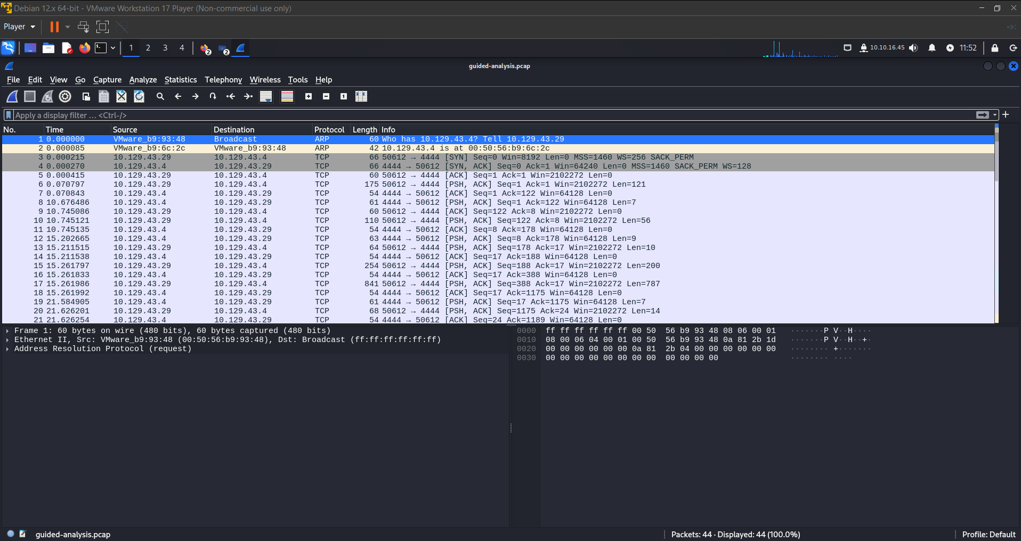

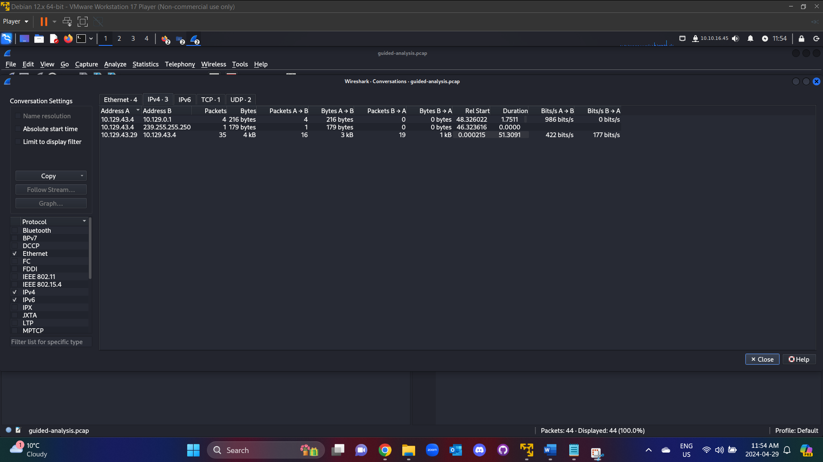

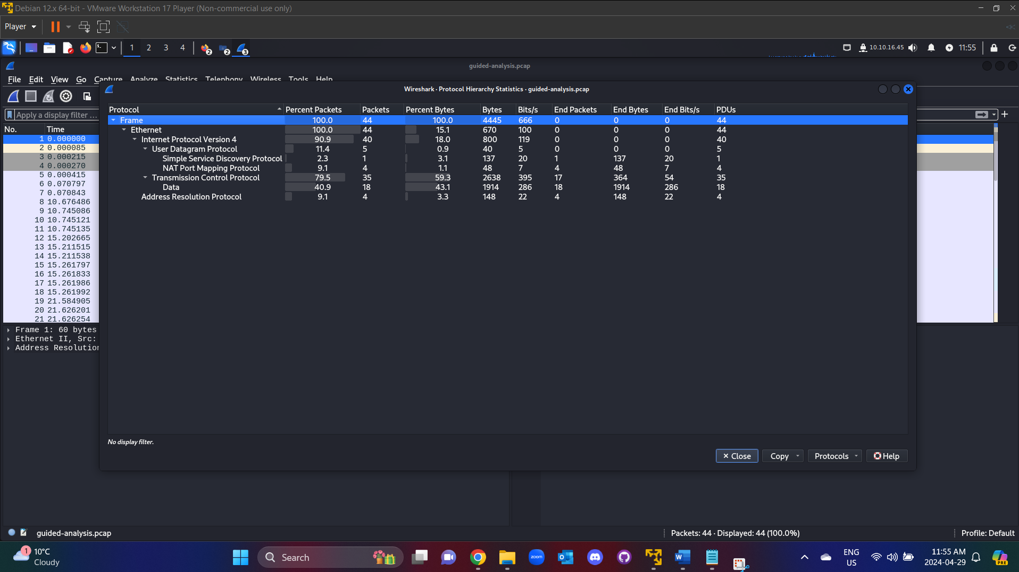

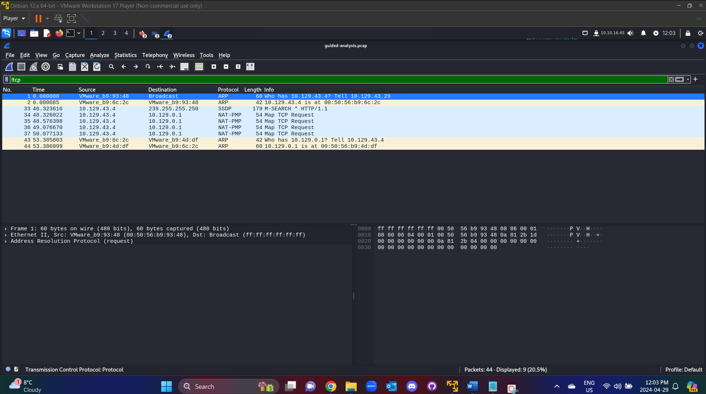

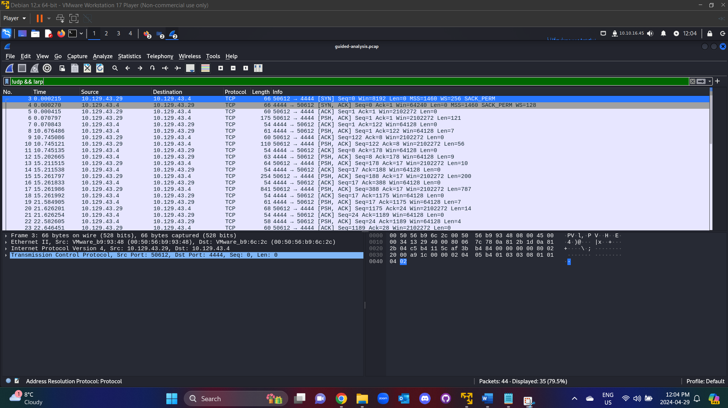

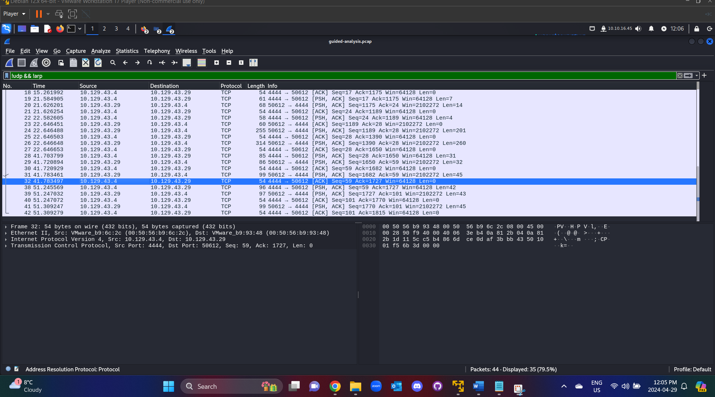

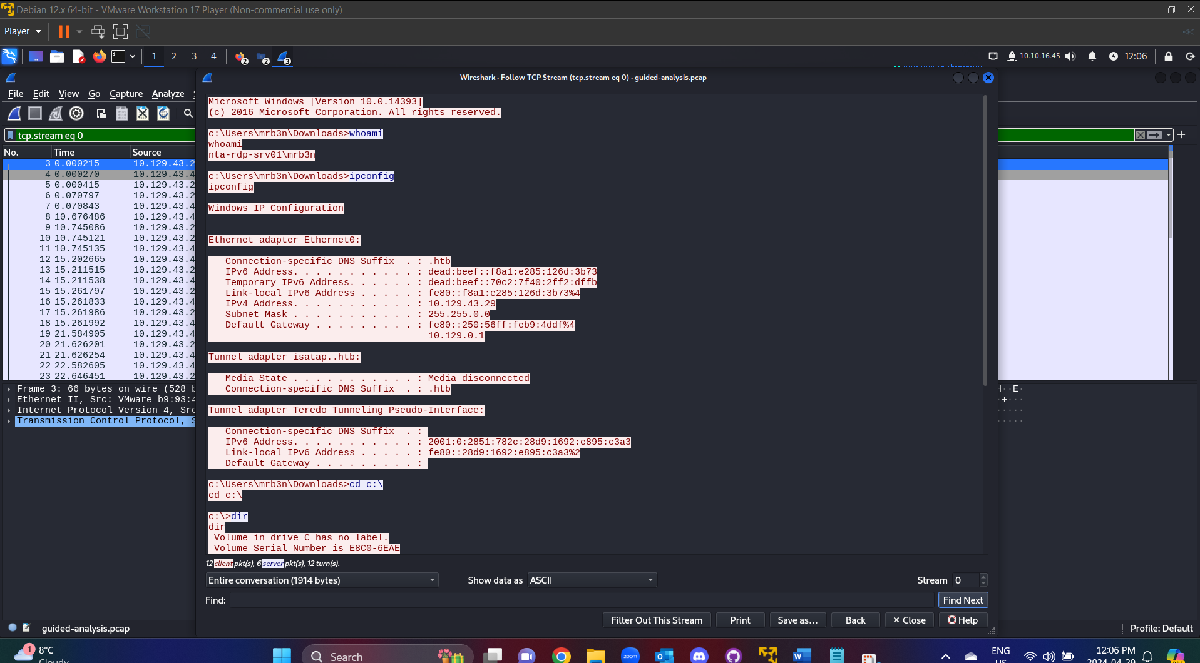

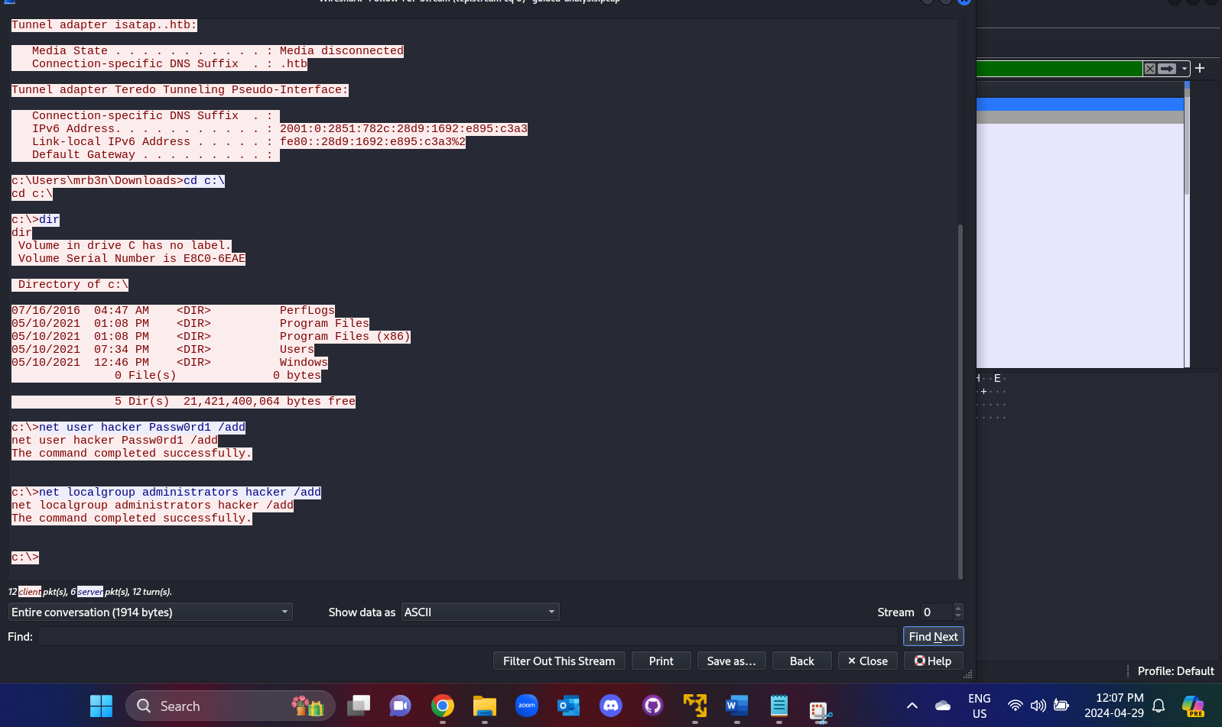

**Decrypting RDP connections**

**Task #1**

Open the rdp.pcapng file in Wireshark.

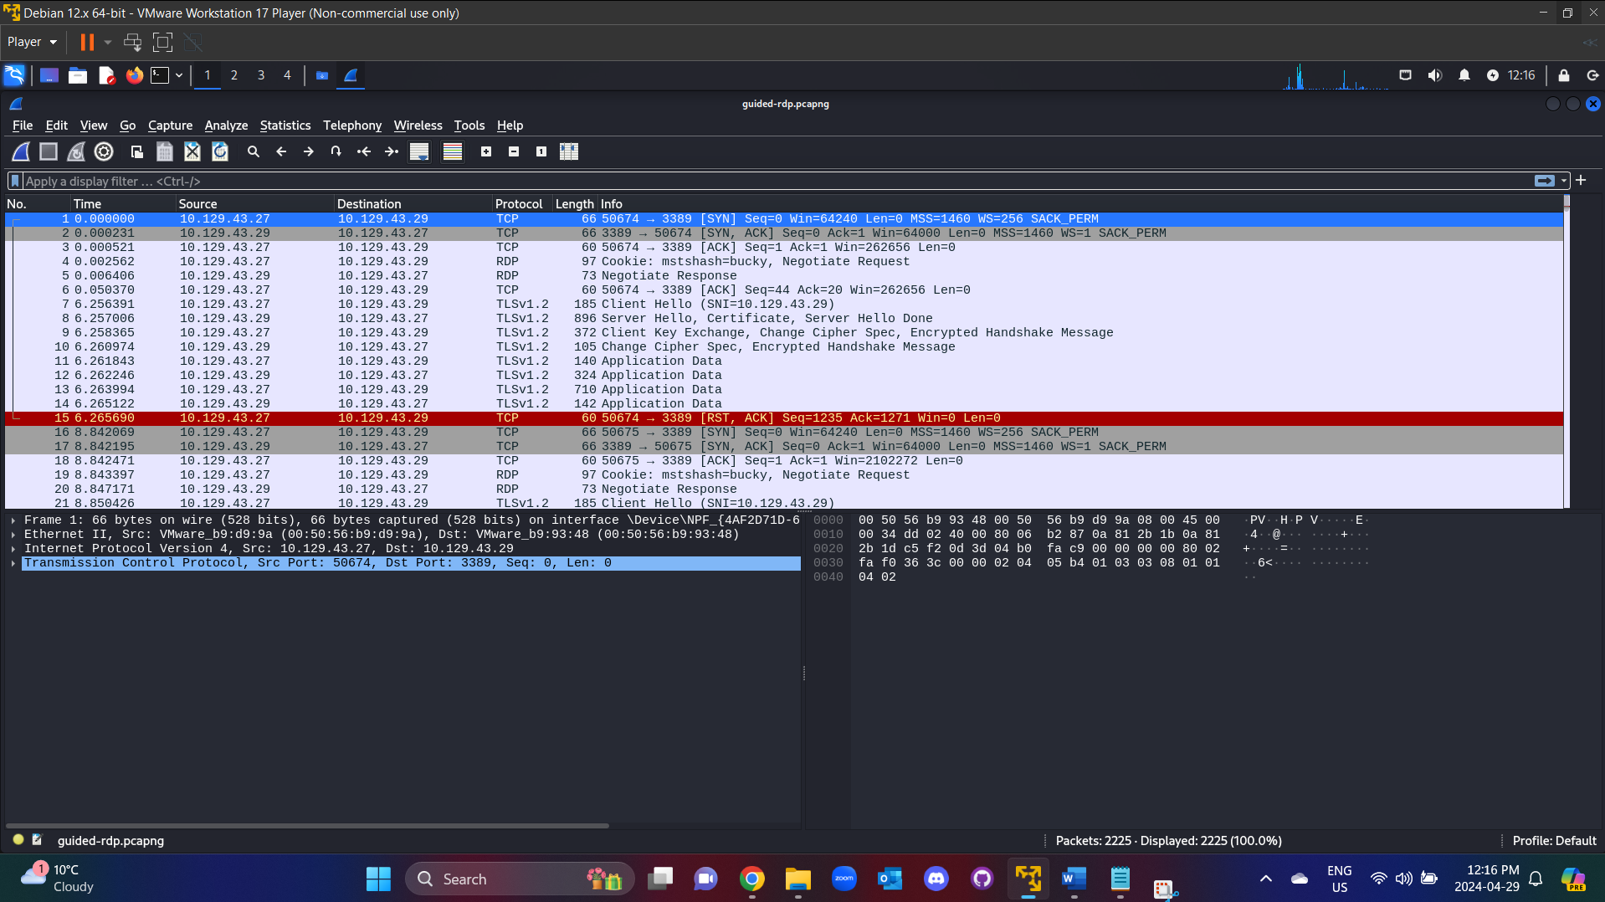

**Task #2**

Analyze the traffic included.

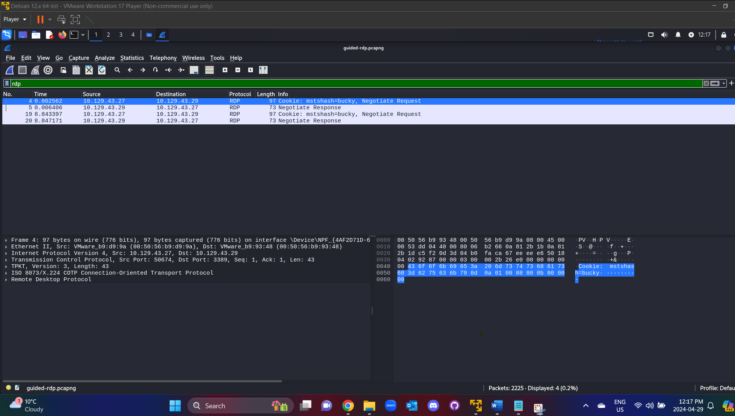

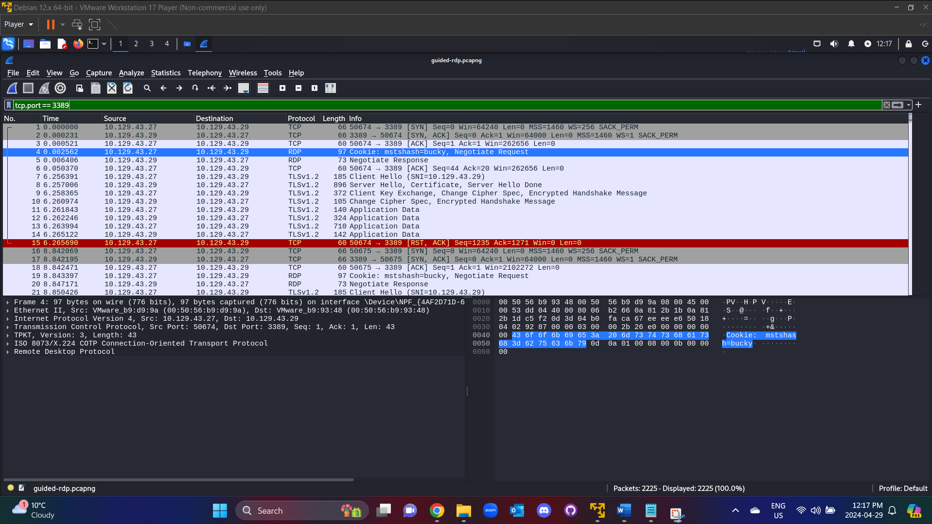

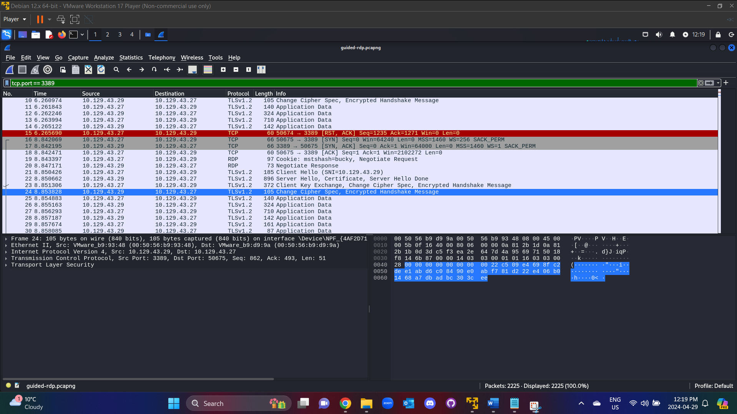

**Task #3**

Provide the RDP-key to Wireshark so it can decrypt the traffic.

